What’s so special about Fibonacci?

XY-metallic ratio generation for recurrence relations of 2 initial terms

# Abstract

Does the golden ratio exist in recurrence relations other than the Fibonacci sequence, given two initial terms?

# Mathematical review

Fibonacci numbers have been known since the 13th century. They are well-known, due to their various applications in nature and visual art (among other fields). The Fibonacci sequence is a specific instance of a recurrence relation, where a recurrence relation is defined as:

$$a\left(n\right)=\sum_{i=n-N}^{n-1}{a\left(i\right), n>N [1]}$$

Specifically, the Fibonacci sequence has 2 initial terms of 1 and 1. Each subsequent term is defined as the sum of the two previous terms:

$$F_{n}= F_{n-1}+F_{n-2}$$

The significance of this sequence is that the ratio between a term and its predecessor tends to a constant value as n grows. This ratio, known as the Golden Ratio, is essential to the mathematics of aesthetics. It is defined as, for arbitrarily large n:

$$\frac{F_{n}}{F_{n-1}}=\frac{F_{n-1}}{F_{n-2}}=…=ϕ$$

However, the Fibonacci sequence can itself be generalised. For example, Pell noted that $\sqrt{2}$ could be defined as the ratio of the following recurrence relation:

$$F_{n}= {NF}_{n-1}+F_{n-2} where N=2 [2]$$

The ratio that Pell discovered was known as the Silver Ratio, as it was similar to the Golden Ratio. As N increases, the ratios are defined as “metallic”.

# Original Definitions

XY-metallic – a recurrence relationship derived from the Lucas sequence (second term is negated). X and Y represent variables, rather than constants, in Cartesian Space:

$$F_{n}=xF_{n-1}+yF_{n-2}$$

XY-metallic ratio: a generalised form of the metallic ratio, given with respect to x and y. Graphically, this also represents the Cartesian z-axis:

$$Δ_{(x,y)}=\frac{F_{n}}{F_{n-1}}=z$$

# Defining the XY-metallic ratio

Given that:

$$F_{n}=xF_{n-1}+yF_{n-2}$$

Assume:

$$F_{n-1}=xF_{n-2}+yF_{n-3}$$

$$Δ_{(x,y)}=z=\frac{F_{n}}{F_{n-1}}=\frac{xF_{n-1}+yF_{n-2}}{xF_{n-2}+yF_{n-3}}$$

As the sequence is only defined with 2 initial terms, Fn-3 must be eliminated:

$$yF_{n-3}=F_{n-1}-xF_{n-2}$$

Substitute into ratio. Let z = $Δ_{(x,y)}$:

$$z=\frac{F_{n}}{F_{n-1}}=\frac{xF_{n-1}+yF_{n-2}}{xF_{n-2}+(F_{n-1}-xF_{n-2})}$$

Simplify equation through cancellation:

$$z=\frac{xF_{n-1}+yF_{n-2}}{F_{n-1}}$$

Separate fraction:

$$z=x\frac{F_{n-1}}{F_{n-1}}+y\frac{F_{n-2}}{F_{n-1}}$$

Simplify:

$$z=x+y\frac{F_{n-2}}{F_{n-1}}$$

Note, from the definition of the Golden Ratio that:

$$\frac{F_{n}}{F_{n-1}}=\frac{F_{n-1}}{F_{n-2}}=…=ϕ$$

However, this is axiomatically true for any XY-metallic ratio:

$$\frac{F_{n}}{F_{n-1}}=\frac{F_{n-1}}{F_{n-2}}=…=z=Δ_{(x,y)}∀ x,y$$

Therefore, simplify:

$$z=x+y\frac{1}{z}$$

Multiply both sides by $z$:

$$z^{2}=xz+y$$

$$z^{2}-xz-y=0$$

Solve for z. Define in terms of x and y:

$$z=\frac{x±\sqrt{x^{2}+4y}}{2}$$

Mapping this function (where z=f(x, y) in Cartesian space yields the following graph:

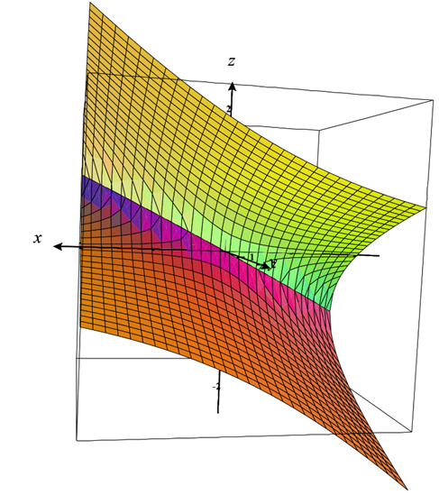

Figure - z vertical, x horizontal, y towards viewer [[3]](https://www.monroecc.edu/faculty/paulseeburger/calcnsf/CalcPlot3D/)

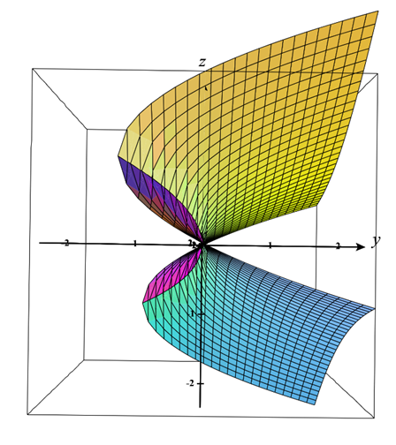

Figure - z vertical, y horizontal, x towards viewer [[3]](https://www.monroecc.edu/faculty/paulseeburger/calcnsf/CalcPlot3D/)

Here, the z-axis represents the xy-metallic ratio. When y=1, the z-axis describes all metallic ratios with respect to x

# Redefining the Golden Ratio

It has been known throughout history that the ratio of a Fibonacci number and its predecessor tends to the Golden Ratio as Fn grows.

Fibonacci numbers, as defined above, occur when the coefficient applied to each number in a 2-term Lucas sequence is 1:

$$z^{2}-xz-y=0$$

$$x,y=1 ∴ z^{2}-z-1=0$$

$$z=\frac{1±\sqrt{5}}{2}$$

However, the model described above uses variable coefficients instead of constants, as Lucas did. Therefore, there are multiple solutions that lead to the Golden Ratio.

As ratios are not defined for negative values, the positive version of it shall be used. This is consistent with the rest of mathematics.

$$Let z=ϕ=\frac{1+\sqrt{5}}{2}$$

Substitute for z:

$${(\frac{1+\sqrt{5}}{2})}^{2}-x(\frac{1+\sqrt{5}}{2})-y=0$$

$$x\left(\frac{1+\sqrt{5}}{2}\right)+y= {(\frac{1+\sqrt{5}}{2})}^{2}$$

Rearrange for y and factorise:

$$y=\left(\frac{1+\sqrt{5}}{2}\right)\left(\frac{1+\sqrt{5}}{2}-x\right)$$

$$y=\frac{1+\sqrt{5}}{2}×\frac{1-2x+\sqrt{5}}{2}$$

$$y=\frac{\left(1+\sqrt{5}\right)\left(1-2x+\sqrt{5}\right)}{4}$$

$$y=\frac{1+\sqrt{5}+\sqrt{5}+5+\left(-2x\right)+(-2x\sqrt{5})}{4}$$

$$y=\frac{6+2\sqrt{5}+\left(-2x\right)+(-2x\sqrt{5})}{4}$$

$$y=\frac{6+2\sqrt{5}-2x(1+\sqrt{5})}{4}$$

$$y=\frac{3+\sqrt{5}-x\left(1+\sqrt{5}\right)}{2}$$

As shown above, y is expressed in terms of x. Going back to the thesis of this paper:

$$F_{n}=xF_{n-1}+yF_{n-2}$$

We can replace y:

$$F_{n}=xF_{n-1}+\left[\frac{3+\sqrt{5}-x\left(1+\sqrt{5}\right)}{2}\right]F_{n-2}$$

As z is the Golden Ratio, then any xy-metallic series with these coefficients will converge to a Golden Ratio

# Bolt sequence

This is an arbitrary sequence of numbers used to exemplify the above formula. Its ratio will converge to the Golden Ratio:

$$B_{1},B_{2}=1$$

$$x=\frac{π^{2}}{6} ∴y=\left(\frac{1+\sqrt{5}}{2}\right)\left(\frac{1+\sqrt{5}}{2}-\frac{π^{2}}{6}\right)$$

$$B_{3}=\frac{π^{2}}{6}+\left(\frac{1+\sqrt{5}}{2}\right)\left(\frac{1+\sqrt{5}}{2}-\frac{π^{2}}{6}\right)$$

$$B_{4}=\frac{π^{2}}{6}\left[\frac{π^{2}}{6}+\left(\frac{1+\sqrt{5}}{2}\right)\left(\frac{1+\sqrt{5}}{2}-\frac{π^{2}}{6}\right)\right]+\left(\frac{1+\sqrt{5}}{2}\right)\left(\frac{1+\sqrt{5}}{2}-\frac{π^{2}}{6}\right)$$

To prove this assertion, B4/B3 must approximate the Golden Ratio:

$$Let u=\frac{1+\sqrt{5}}{2}-\frac{π^{2}}{6}$$

$$B_{4}=\frac{π^{2}}{6}\left[\frac{π^{2}}{6}+\left(\frac{1+\sqrt{5}}{2}\right)u\right]+\left(\frac{1+\sqrt{5}}{2}\right)u$$

$$B_{3}=\frac{π^{2}}{6}+\left(\frac{1+\sqrt{5}}{2}\right)u$$

Multiply out B4: